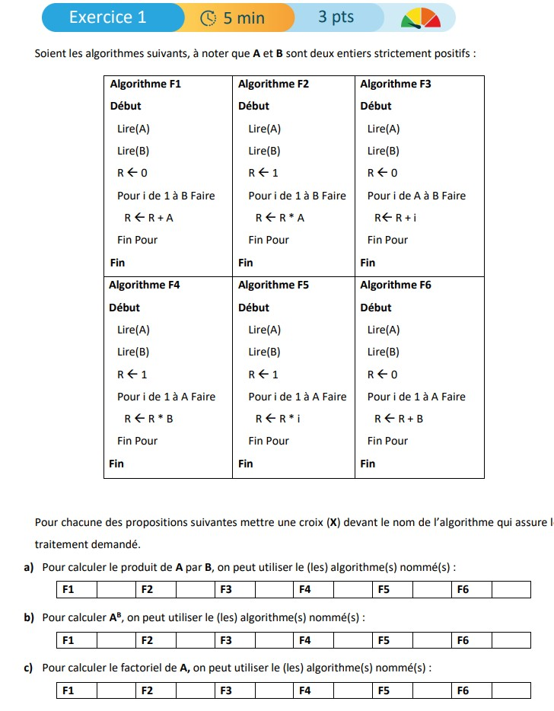

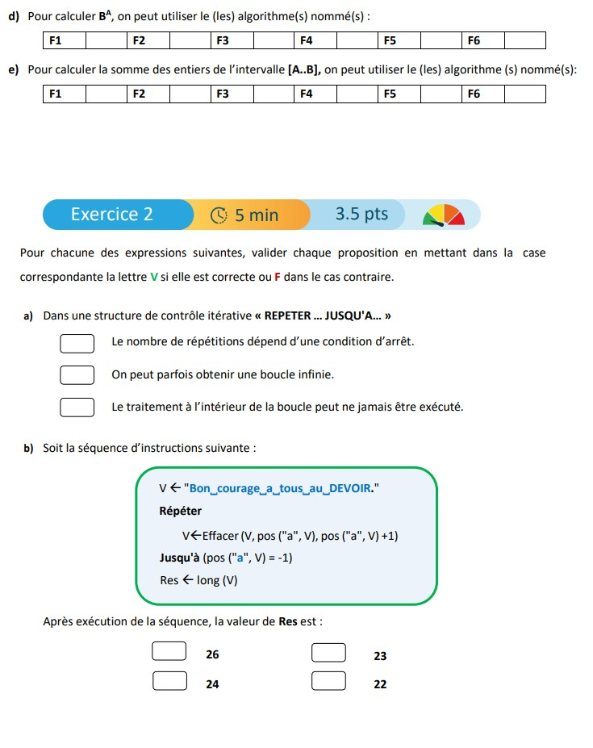

correction

X
X
X
X

correction

F
F
V
V
V
F
F
X
X

